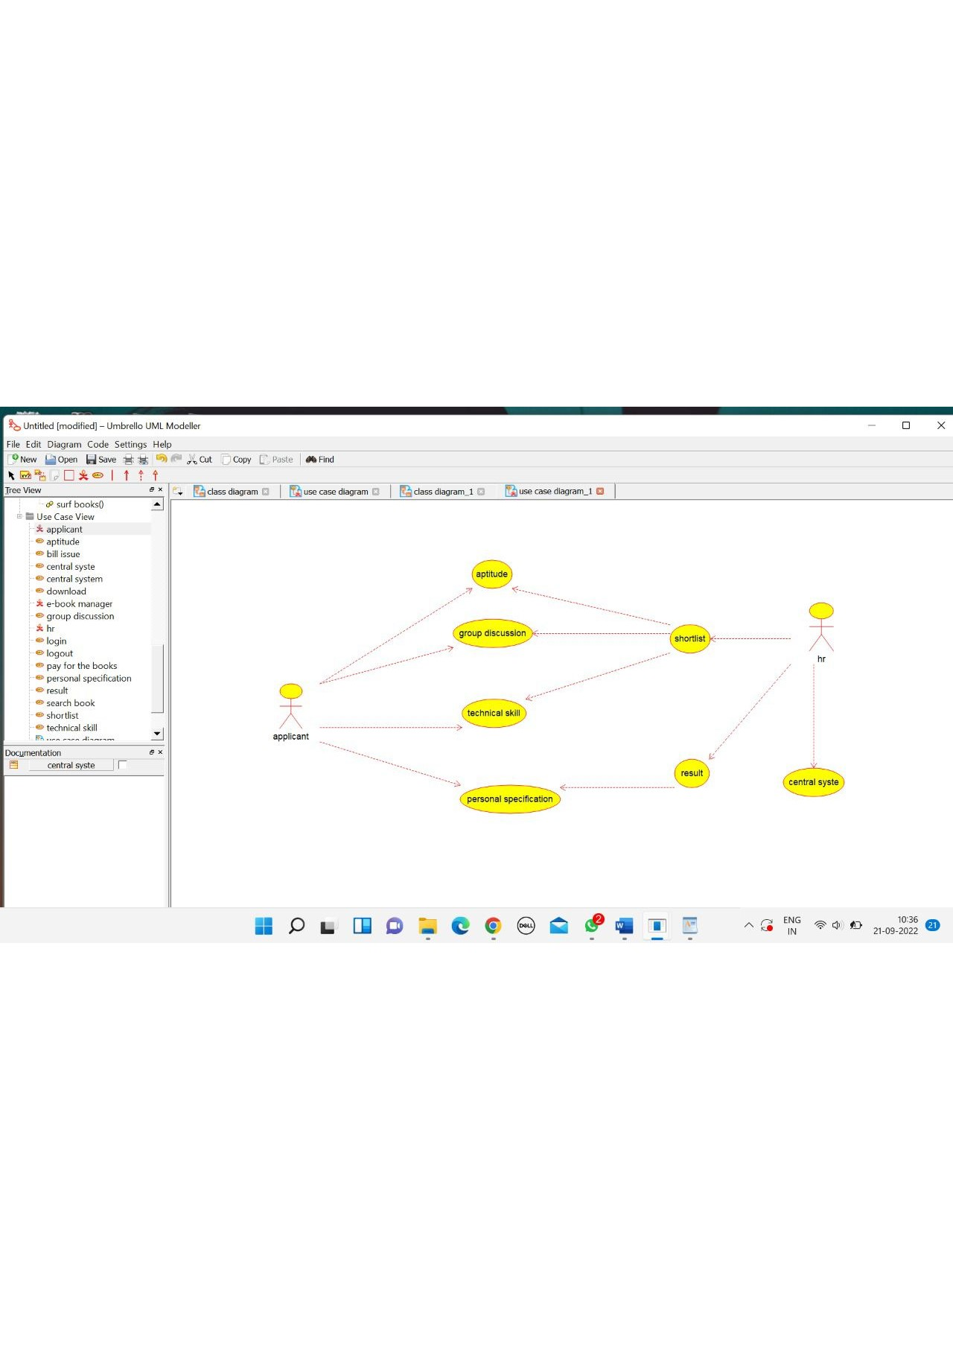

CANDIDATE

/**

* Class CANDIDATE

*/

public class CANDIDATE {

//

// Fields

//

private void name;

private void operation;

private void qualification;

//

// Constructors

//

public CANDIDATE () { };

//

// Methods

//

//

// Accessor methods

//

/**

* Set the value of name

* @param newVar the new value of name

*/

private void setName (void newVar) {

name = newVar;

}

/**

* Get the value of name

* @return the value of name

*/

private void getName () {

return name;

}

/**

* Set the value of operation

* @param newVar the new value of operation

*/

private void setOperation (void newVar) {

operation = newVar;

}

/**

* Get the value of operation

* @return the value of operation

*/

private void getOperation () {

return operation;

}

/**

* Set the value of qualification

* @param newVar the new value of qualification

*/

private void setQualification (void newVar) {

qualification = newVar;

}

/**

* Get the value of qualification

* @return the value of qualification

*/

private void getQualification () {

return qualification;

}

//

// Other methods

//

/**

*/

public void verify()

{

}

/**

*/

public void candidate()

{

}

}

HR

/**

* Class H_R

*/

public class H_R {

//

// Fields

//

private void verification;

private void resume;

//

// Constructors

//

public H_R () { };

//

// Methods

//

//

// Accessor methods

//

/**

* Set the value of verification

* @param newVar the new value of verification

*/

private void setVerification (void newVar) {

verification = newVar;

}

/**

* Get the value of verification

* @return the value of verification

*/

private void getVerification () {

return verification;

}

/**

* Set the value of resume

CENTRAL SYSTEM

/**

* Class CENTRAL_SYSTEM

*/

public class CENTRAL_SYSTEM {

//

// Fields

//

private void store;

private void update;

//

// Constructors

//

public CENTRAL_SYSTEM () { };

//

// Methods

//

//

// Accessor methods

//

/**

* Set the value of store

* @param newVar the new value of store

*/

private void setStore (void newVar) {

store = newVar;

}

/**

* Get the value of store

* @return the value of store

*/

private void getStore () {

return store;

}

/**

* Set the value of update

* @param newVar the new value of update

*/

private void setUpdate (void newVar) {

update = newVar;

}

/**

* Get the value of update

* @return the value of update

*/

private void getUpdate () {

return update;

}

//

// Other methods

//

/**

*/

public void central_system()

{

}

